BIG DATA LAB

Name:S.L.A.Laisha

USN:1NT19IS147

SEC:C1

Date: 05-04-2022

To check if Mongodb is installed or not and version:

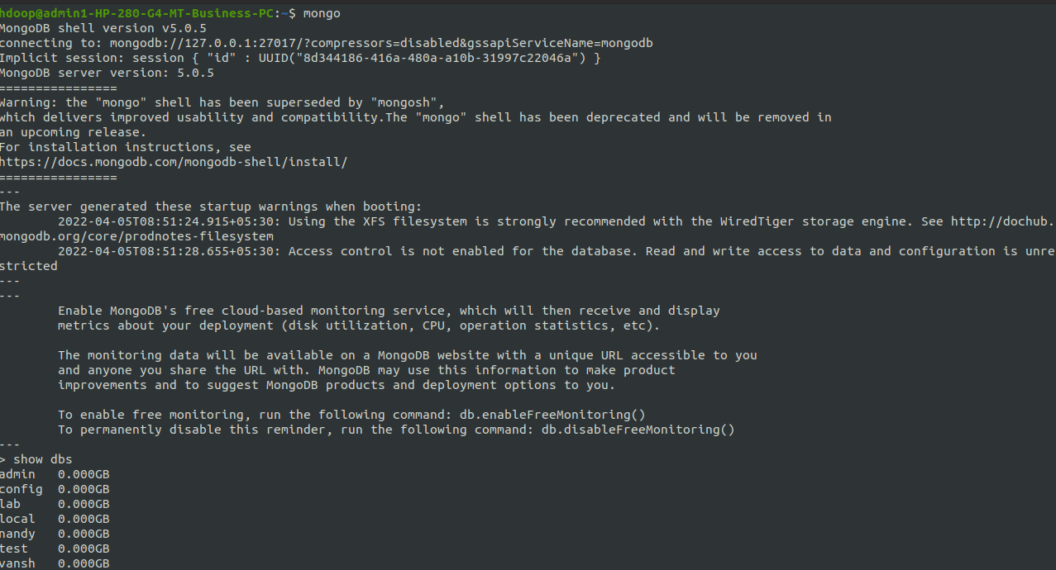

To start mongodb:

>Mongo

To check the databases present

>show dbs

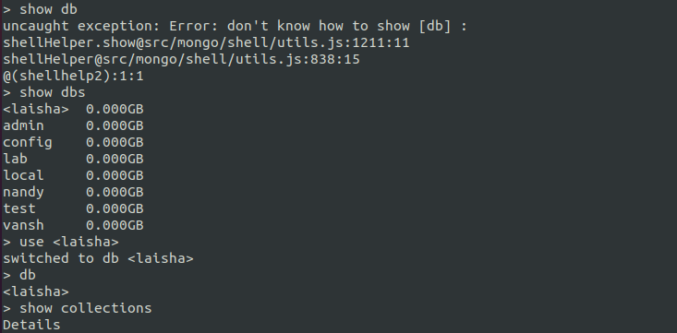

Now creating the database,if its already present then it will use that database otherwise it will create new database with that name

use<laisha>

Using db command we can find the current database we are using.

To display the database name in show dbs atleast one value should be inserted..

If no values are present then that database will be deleted.

Creating a collection in the database:

db.createCollection(“names”)

To display the commands we use

Show collections

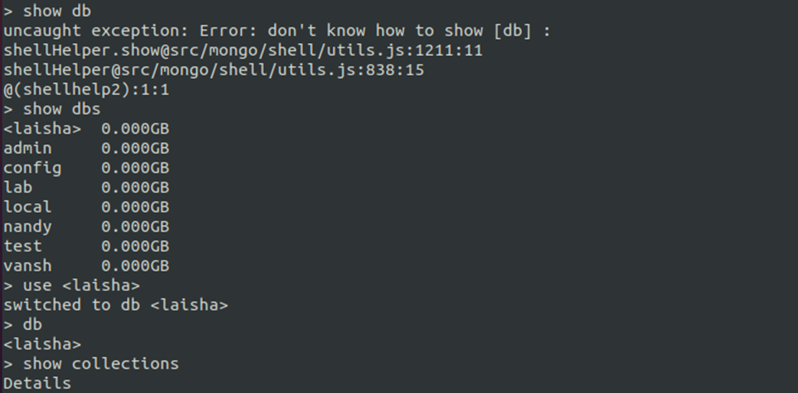

Inserting one value to the collection created

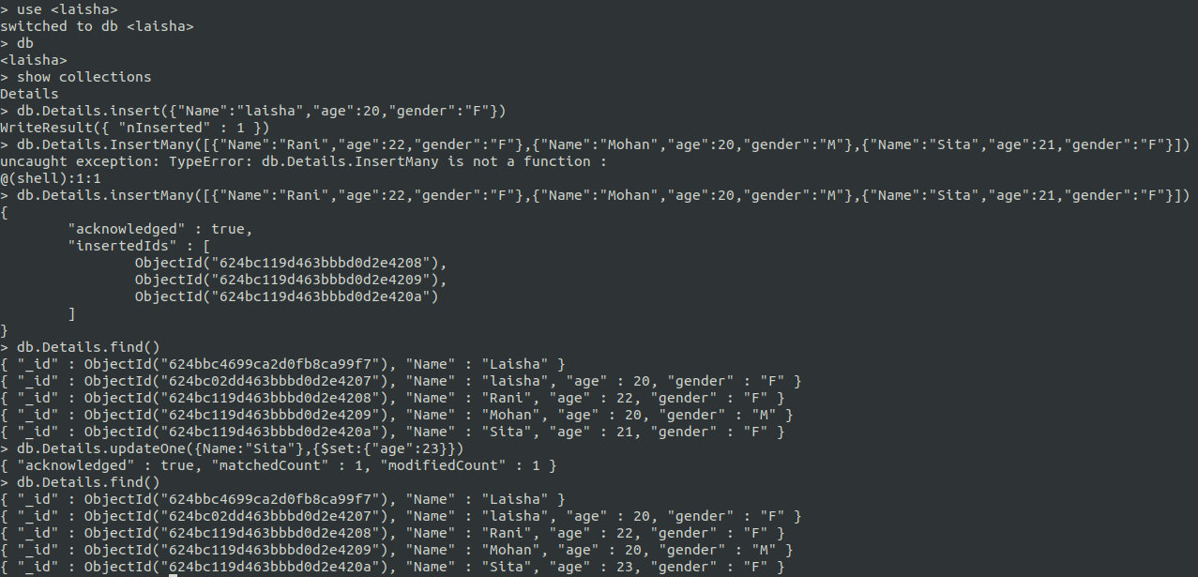

Inserting multiple values to the collection created

>db.Details.find() —--used to print the values inserted

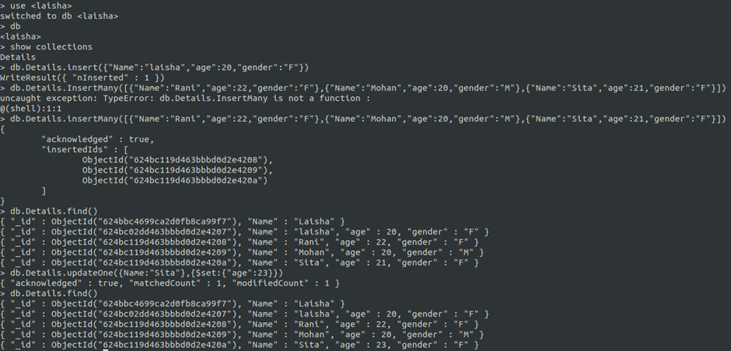

Updating a single value

>db.Details.updateone({Name:”Sita”},{$set:{“age”:23}})

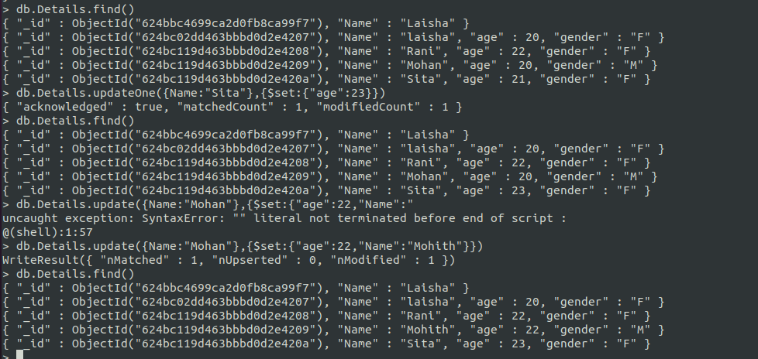

Sita’s age is updated from 21 to 23

Updating multiple values

>db.Details.update({Name:”Mohan”},{$set:{“age”:22,”Name”:”Mohith”}})

